



**Project Type: Relational Database**

**Akshay Maan**

**Product Dissection for Instagram**

**Company Overview:**

Instagram is an internet-based social media platform and service that facilitates the sharing of photos and videos. Co-founded in 2010 by Kevin Systrom and Mike Krieger, the application quickly gained popularity for its user-friendly interface and innovative features. As Instagram gained popularity, Facebook made a bid to acquire it in the year 2012, for a record setting bid of $1 Billion. Instagram became really famous after Facebook bought it. Now, it's known all over the world as a cool social media app. People love it because it's easy to use and lets them share pictures and videos. Instagram has a lot of users from everywhere, and it's one of the most popular apps for talking to friends and sharing cool stuff.

**Product Dissection and Solutions to Real-World Challenges by Instagram:**

Instagram is a social networking service for sharing photos and videos that was launched in 2010. It has since become one of the most popular social media platforms in the world, with over **1 billion** monthly active users as of 2021

Instagram allows users to take pictures and videos, apply digital filters, and share them on their profiles or with their followers. Instagram lets users share photos and videos, but it also has features like messaging, live streaming, and a “discover” page that suggests content based on what users like and do

Instagram’s popularity comes from the fact that it focuses on pictures and is easy to use. The filters and editing tools on the platform make it easy for users to improve the look of their photos and videos.

The platform’s easy-to-use interface also lets users share their content quickly and easily with a large audience. Instagram has also become popular with businesses because it lets them reach a large audience of people who are interested in what they have to say through paid posts and partnerships with influencers.

In conclusion, Instagram has become a globally acclaimed social media platform. Its user-friendly design focuses on easy photo and video sharing, enhanced by digital filters and additional features like messaging, live streaming, and a personalized "discover" page. Instagram's widespread popularity stems from its emphasis on visual content and ease of use, allowing users to quickly share with a broad audience. Notably, businesses leverage Instagram's reach through paid posts and partnerships with influencers.

**Case Study: Real-World Problems and Instagram's Innovative Solutions**

Instagram, a groundbreaking social media platform, has played a vital role in tackling real-world issues with its creative product solutions. It fixed real-world problems by using cool features. Instagram helps people connect, express themselves, and make online interactions better by understanding what users want and using technology. Let's explore the dissection of Instagram's products and how they address practical problems:

**Problem 1**

**Digital Disconnect:**

**Problem**: As digital interactions become more prevalent, users often struggle to convey emotions and experiences effectively through text alone, leading to a disconnect in online relationships.

**Instagram's Solution**: The platform addresses this by allowing users to share photos and videos alongside captions, locations, and hashtags, creating a visually rich environment for more authentic digital expression.

**Problem 2**

**Maintaining Genuine Connections:**

**Problem**: In the digital age, maintaining genuine connections can be challenging, as online interactions may lack the depth of real-world relationships.

**Instagram's Solution**: Features like likes, comments, and direct messaging facilitate meaningful interactions, bridging the gap between digital and real-world connections, allowing users to engage authentically with others.

**Problem 3**

**Overcoming Geographic Boundaries**:

**Problem**: Physical distances can pose a challenge in connecting with people from different parts of the world, limiting the diversity of social interactions.

**Instagram's Solution**: The platform's global reach allows users to connect with individuals worldwide, breaking down geographical boundaries and fostering a diverse and inclusive community.

**Problem 4**

**Visual Storytelling for Brands:**

**Problem:** Traditional advertising methods may struggle to capture audience attention in a visually-driven digital landscape, making it difficult for brands to tell compelling stories.

**Instagram's Solution:** Businesses leverage Instagram's visual format, utilizing photos and videos to create engaging narratives, connect with their audience, and showcase products or services in an immersive way.

**Problem 5**

**Digital Well-being:**

**Problem:** Excessive use of social media can contribute to feelings of anxiety, stress, and decreased overall well-being.

**Instagram's Solution:** The platform introduced features like time management tools and reminders, empowering users to monitor and manage their screen time, promoting a healthier balance between digital engagement and personal well-being.

In **Conclusion**, Instagram is a versatile solution to modern digital challenges. It helps users express themselves authentically, connect genuinely, overcome distance, and allows businesses to tell engaging stories visually. Additionally, it promotes digital well-being by offering tools to manage screen time. Instagram proves to be a comprehensive solution, making online experiences better and healthier.

**Top Features of Instagram:**

1. **User Profiles**: Profiles on Instagram let users make their own personal space. You can add your username, full name, bio, and profile picture to share insights about yourself.
2. **Sharing on Instagram**: Instagram lets you share photos and videos, make them more fun with filters and stickers, and add captions to create a lively visual story. The platform encourages engagement with likes, comments, and the option to save content for later viewing.
3. **Direct Messaging:** Instagram's messaging feature enables users to send private messages, photos, and videos directly to individuals or groups, enhancing one-on-one or small group interactions.
4. **Instagram Live:** Users can broadcast live videos, engaging with their audience in real-time and allowing for interactive sessions with followers.
5. **Shopping Features:** Instagram facilitates e-commerce through features like Instagram Shops, where businesses can showcase and sell products directly on the platform, enhancing the shopping experience for users.
6. **Notifications:** Instagram's notification system keeps users informed about likes, comments, and new followers, ensuring they stay connected and engaged with their online community.

**Schema Description:**

The Instagram schema comprises key entities defining its functionalities. User Profile captures user details like username and bio. Posts include post ID, user ID, and caption for visual storytelling. Direct Messaging involves message details for private interactions. Live Video captures real-time engagement metrics. Shopping Feature supports e-commerce with product details. Notifications keep users informed about interactions. This concise schema forms the backbone of Instagram's diverse features.

**Entities and Attributes:**

* **User Profile Entity:**

**UserID (Primary Key):** A unique identifier for each user.

**Username:** The chosen username for the user's account.

**Full_Name:** The user's full name as displayed on their profile.

**Bio:** A brief description that users can use to express themselves.

**Profile_Picture:** The image representing the user on their profile.

* **Post Entity:**

**PostID (Primary Key):** A unique identifier for each post.

**UserID (Foreign Key Referencing User Profile Entity):** The user who created the post.

**Caption:** Text accompanying the post, providing context.

**Image_URL:** The URL of the image or video content.

**Post_Date:** The date when the post was created.

* **Direct Messaging Entity:**

**MessageID (Primary Key):** A unique identifier for each message.

**SenderUserID (Foreign Key Referencing User Profile Entity):** The user sending the message.

**ReceiverUserID (Foreign Key Referencing User Profile Entity):** The user receiving the message.

**Message_Text:** The content of the message.

**Message_Date:** The date when the message was sent.

* **Live Video Entity:**

**LiveVideoID (Primary Key):** A unique identifier for each live video session.

**UserID (Foreign Key Referencing User Profile Entity):** The user hosting the live video.

**Viewers_Count:** The number of users actively watching the live video.

**Broadcast_Date:** The date and time when the live video was broadcasted.

* **Shopping Feature Entity:**

**ProductID (Primary Key**): A unique identifier for each showcased product.

**ShopID (Foreign Key Referencing User Profile Entity):** The business or user showcasing the product.

**Product_Name:** The name of the product.

**Price:** The cost of the product.

**Availability:** Indicates whether the product is available for purchase.

* **Notification Entity:**

**NotificationID (Primary Key):** A unique identifier for each notification.

**UserID (Foreign Key Referencing User Profile Entity):** The user receiving the notification.

**Notification_Type:** Indicates the type of notification (like, comment, new follower).

**Notification_Date:** The date and time when the notification was generated.

**Relationships are:**

**User Profile and Post:** A user can have multiple posts but each post is associated to one user.

**User Profile and Direct Message:** A user can send and receive multiple messages but each user is associated with one sender and one receiver.

**User Profile and Live Video:** A user can host multiple Live video sessions but each Live video sessions is associated to one user.

**User Profile and Shopping Feature:** A user or business can showcase multiple products but each product is associated with only one user or business.

**User Profile and Notification:** A user can receive multiple notifications but each notification is associated with only one user.

**ER Diagram:**

Let's make a picture that shows how things are connected in Instagram. This picture will help you see the important parts of Instagram and how they work together.

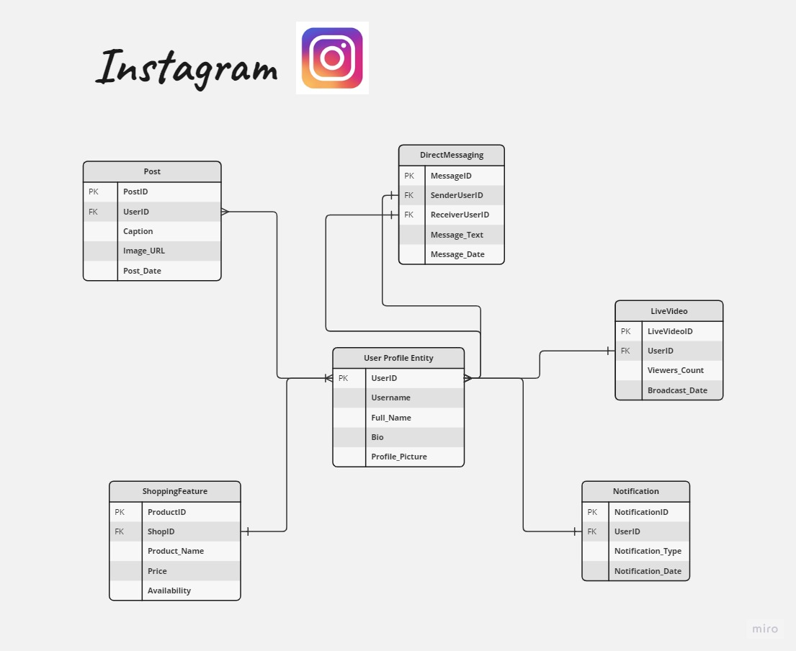

**Conclusion**

In summary, the schema is designed to represent key features of Instagram. User profiles are central, connecting posts, direct messaging, live videos, shopping, and notifications. This setup enables users to share content, communicate privately, engage in live interactions, shop, and stay updated on social interactions. The schema provides a foundation for a user-friendly and interactive platform.